HUMAN SUBJECT INCENTIVES PROGRAM (HSIP) REPORTS IN BUSINESS OBJECTS

Important notes:
- The HSIP reports can be used to reconcile HSIP requests to the Statement of Activity (SOA), as well as to verify completed HSIP requests by Principal Investigator (PI), study, or department.
- The HSIP reports are contained in the FN07 – Human Subject Incentive Pymts universe in the Data Warehouse.
- In order to access the HSIP reports, and OARS (see https://accessrequest.dsc.umich.edu/oars/) request must be submitted. Be sure to request access to the Human Subj Incentive Pmt Data Set when selecting the role in OARS.

STEP-BY-STEP PROCEDURE

- Go to wolverineaccess.umich.edu and select “Faculty & Staff.”

- In the “Reporting” section, select “U-M Data Warehouse (BusinessObjects).”
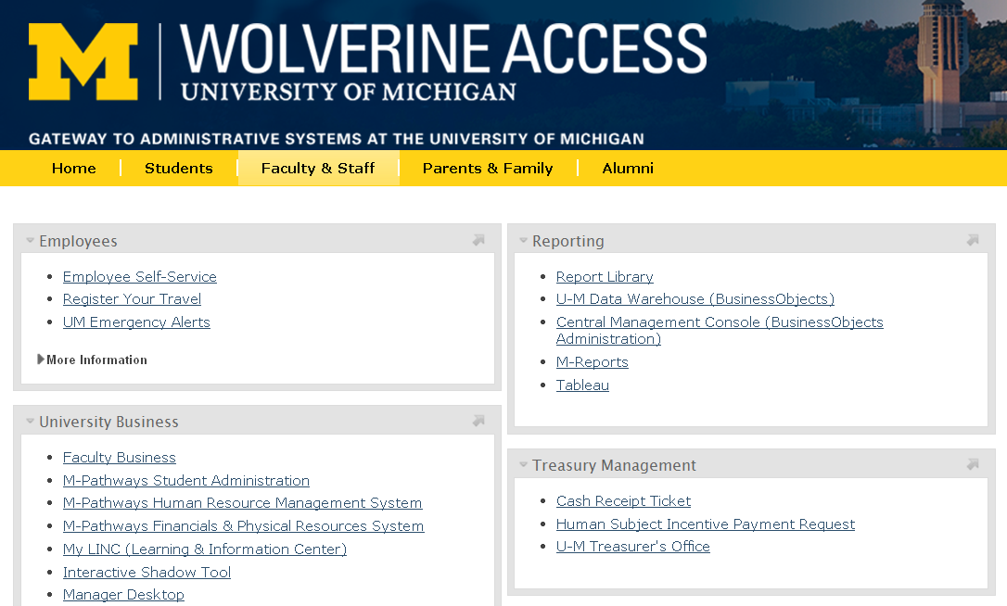

- Login with your uniqname and Kerberos password, as well as two-factor authentication (M-Token).
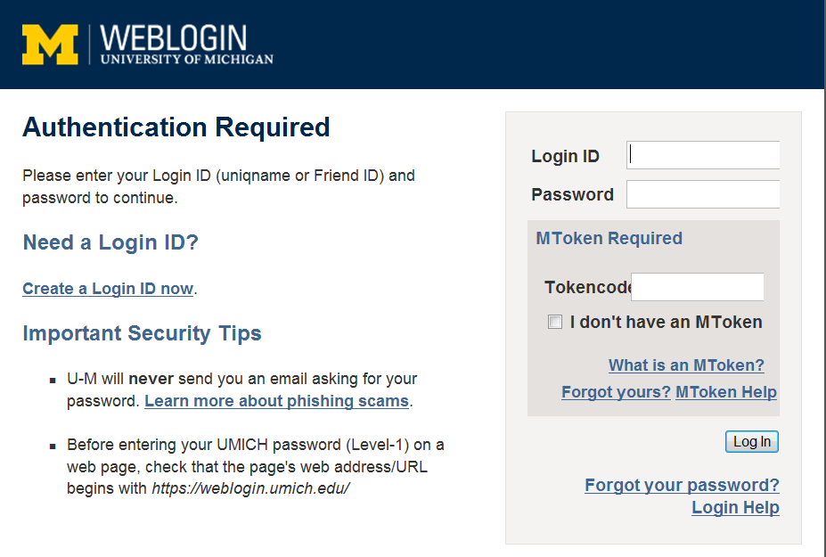

- In BusinessObjects, expand “Public Folders,” then “UM-Maintained,” then “Financials” to locate the “FN07 Human Subject Incentive Pymts” folder. NOTE: If you do not see the folder, you will need to request access to the FN07 universe (see “Important notes” above).
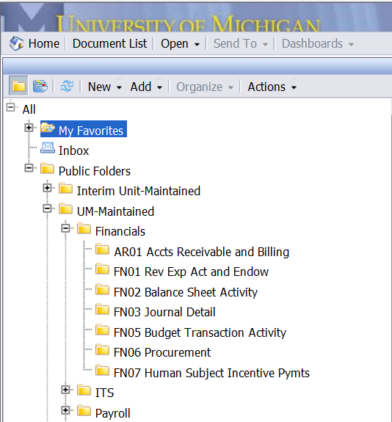

- Select the “FN07 Human Subject Incentive Pymts” folder to view the available reports.
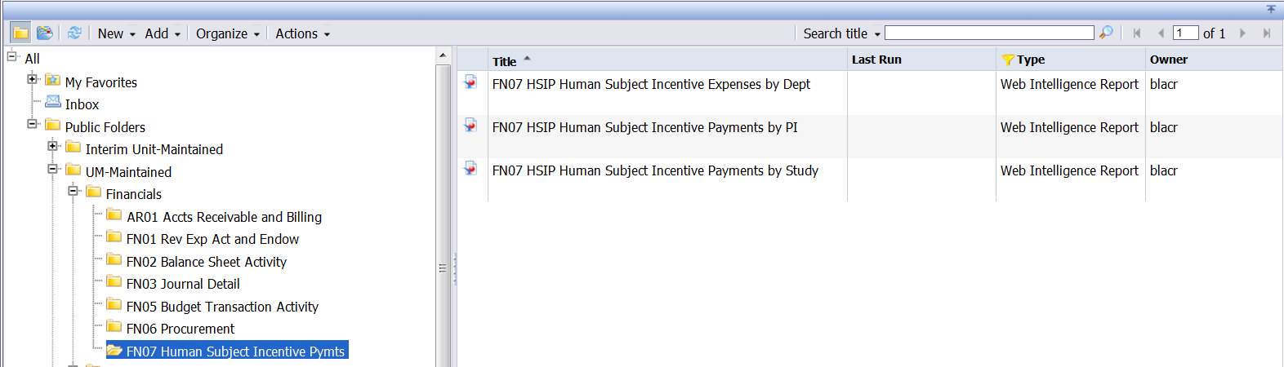

- FN07 HSIP Human Subject Incentive Expense by Dept:
This report provides the following information (on separate tabs within the report):
- HSIP expenses by Project/Grant (P/G)
- HSIP expenses by Fund
- HSIP expense detail (including HSIP control number, PI, journal information, payment type, study tier and expense amount) by P/G
- HSIP expense detail by Fund
- HSIP request information (requester, approver, custodian(s), distribution date, payment type and distribution amount)
Enter the desired filters for the report in the prompt box and click “Run Query”:
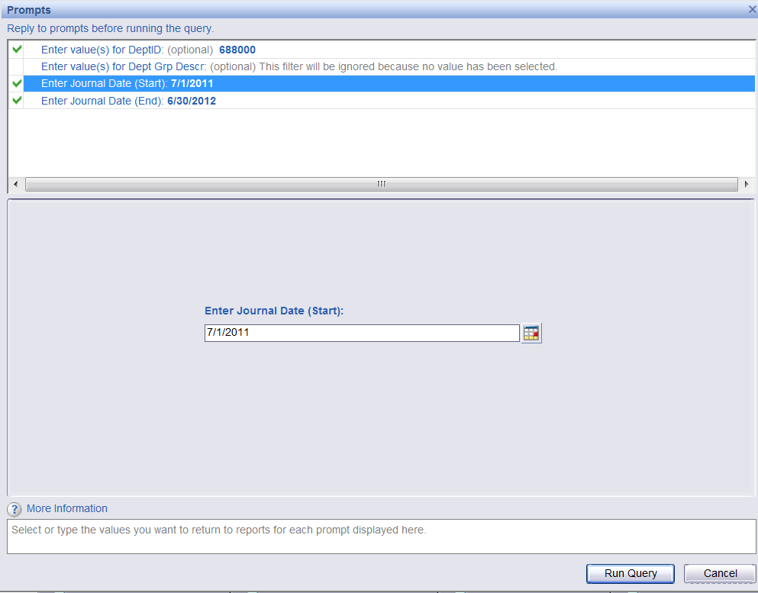

- FN07 HSIP Human Subject Incentive Payments by PI:
This report provides the following information (on separate tabs within the report):
- HSIP payment summary (study number and title, study tier, number of subject payments and total subject payment amount)
- HSIP payment detail by study (HSIP control number, study tier, payment type, number of subject payments, amount paid per subject and total subject payment amount)
Enter the desired filters for the report in the prompt box and click “Run Query”:
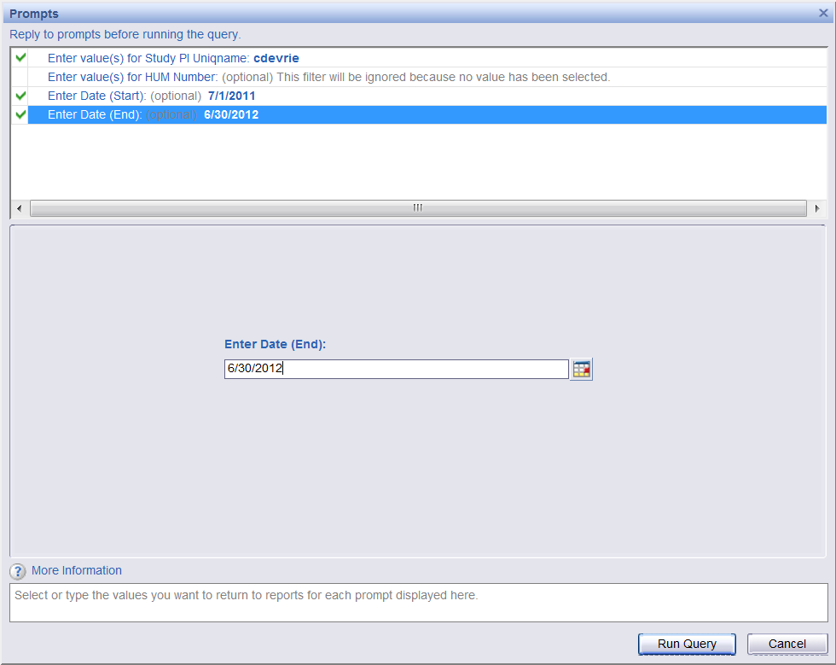

- FN07 HSIP Human Subject Incentive Payments by Study:
This report provides the following information (on separate tabs within the report):
- HSIP payments by study (HSIP control number, subject number, payment date, number of subject payments and total subject payment amount)
- HSIP payments by study by month (payment date year-month, payment date, HSIP control number, subject number, coupon sequence number, number of subject payments and subject payment amount)
Enter the desired filters for the report in the prompt box and click “Run Query”:
