Reporter Web Page
The Nelnet Reporter role provides ability to review/download credit card transaction data.
- Access the Reporter Web page at: https://umich.app.campuscommerce.com/admindashboard
  - NOTE: All assigned roles will be accessible via this link. Previously separate links were used.
- Enter your Login Name and Password; select Log in

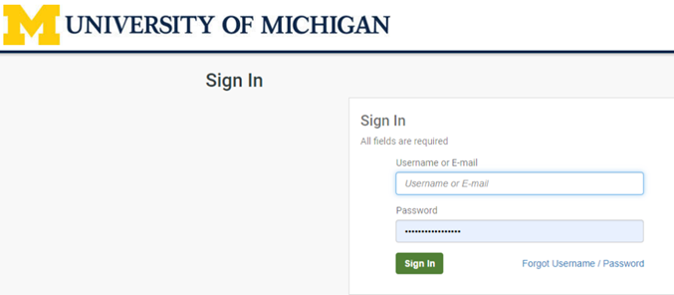

Find Reports
- First time users need to select Change Password and update their password.
- Otherwise, select Reports Summary
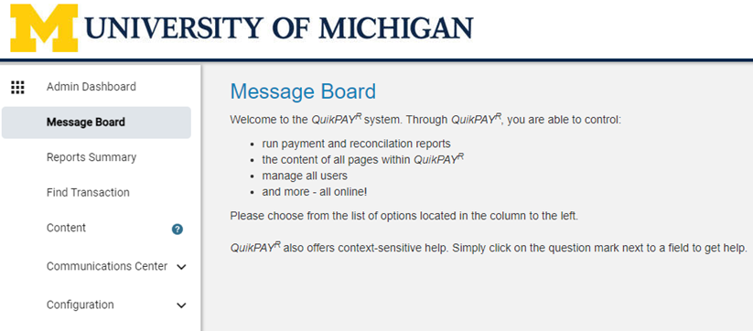

Click on Select Criteria

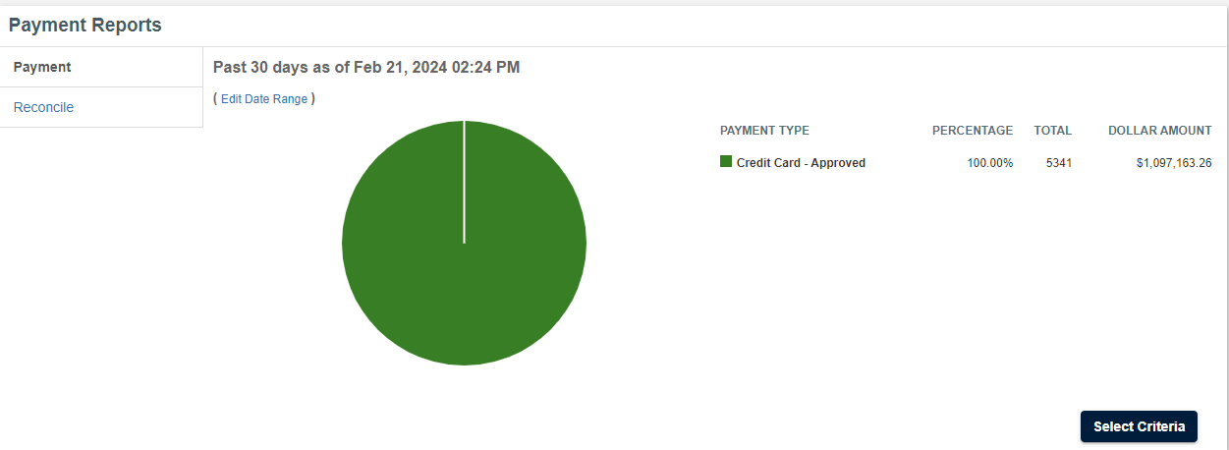
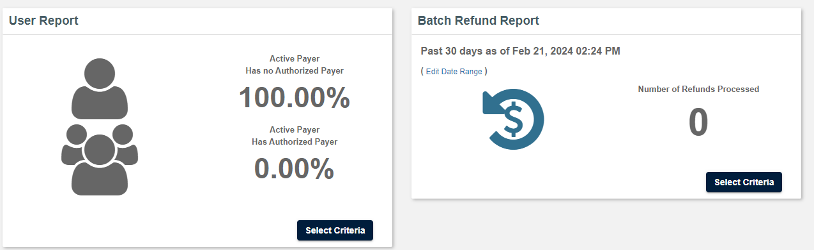

Batch Refunds are very uncommon. Ignore this report.

Report Search Criteria – Time Options
  - Enter report date or date range information in appropriate fields.
  - Find additional info by clicking on the circled question marks.
  - Note: It is possible that dates of Nelnet transactions may not match dates from the UM Statement of Activity or bank monthly statement.

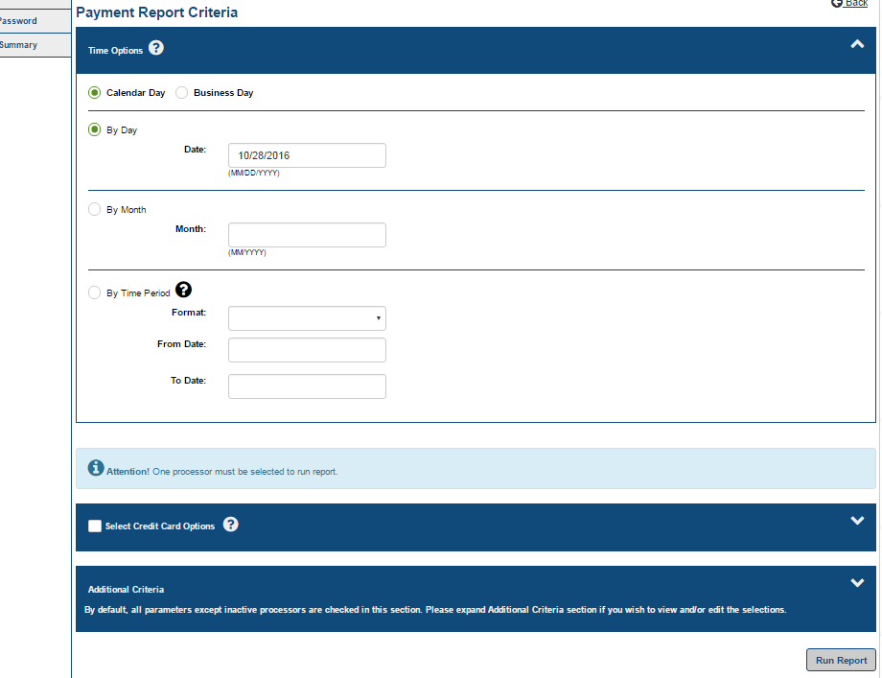

Click on the Select Credit Card Options box and many boxes will become checked.
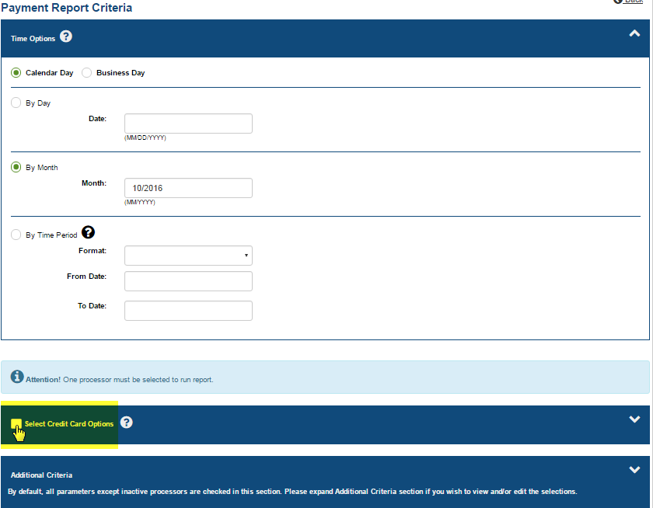

Payment Processor: If you have multiple Payment Processors you can select your payment processor here. See arrow below.
Leave Additional Criteria as is. Click Run Report

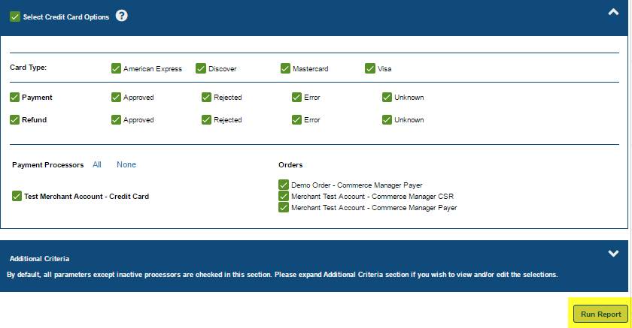

If the data viewed is sufficient, you can download it to Excel or print it.

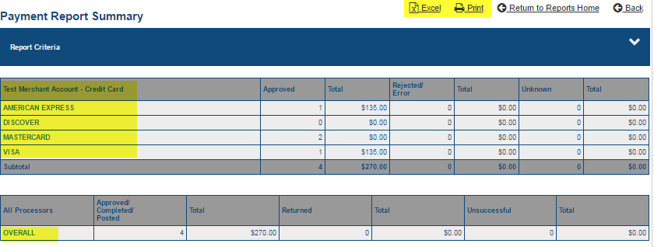

You can also view additional details by click on the various links.
If you click on the merchant name or OVERALL links, you’ll see all transactions and…

If you want even greater transaction details, you can click on the Excel Basic or Excel Detail links and an Excel spreadsheet will be downloaded. The Excel Detail report is especially informative as it will provide every Nelnet detail available about the transactions, including cardholder name, address, email, etc.

