CSR Web Page
The Nelnet CSR role:
- access to locating a particular credit card transaction and, if applicable, the ability to refund it.
- refunds are limited to 180 days from date of transaction.
- refunds do require prior appropriate authorization before transacting.

- Access the CSR Web page at: https://umich.app.campuscommerce.com/admindashboard
  - NOTE: All assigned roles will be accessible via this link. Previously separate links were used.
- Enter your Login Name and Password; select Log in

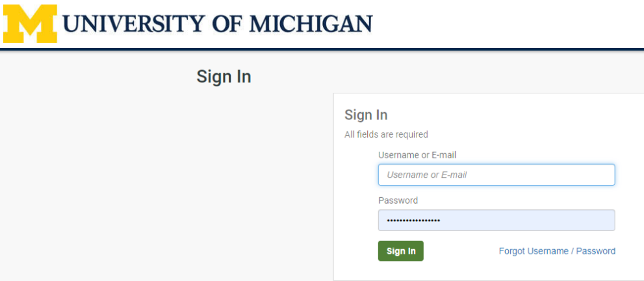

Find Transaction
- First time users need to select Change Password and update their password.
- Otherwise, select Find Transaction
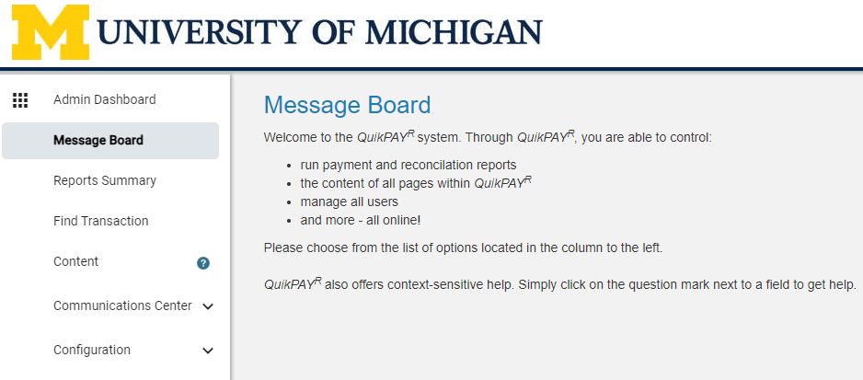

Search Criteria
  - Enter search information in appropriate fields.
  - Find additional info by clicking on the blue circles with question marks.
  - Unless necessary, leave Transaction Criteria boxes checked.
  - Click Search.

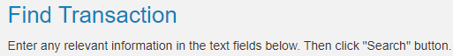
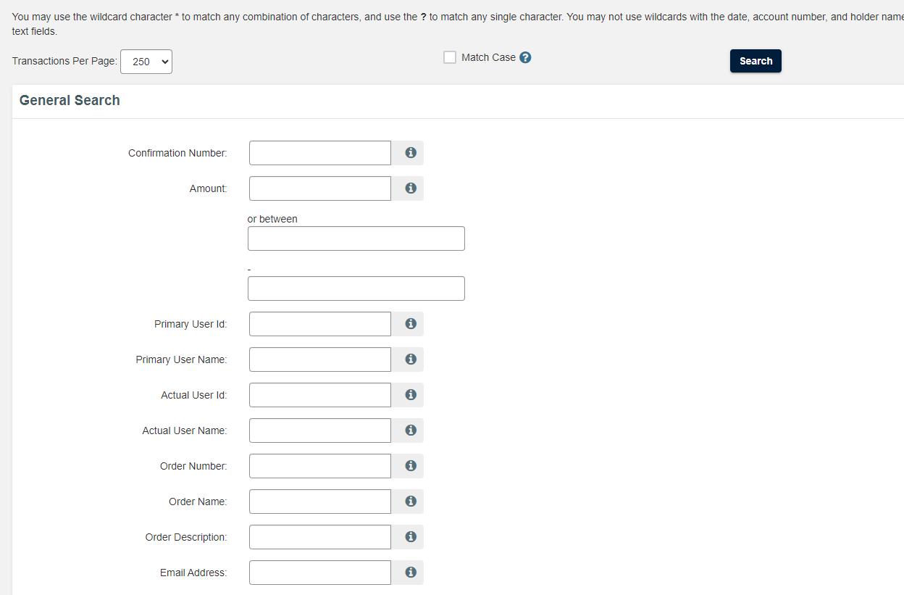
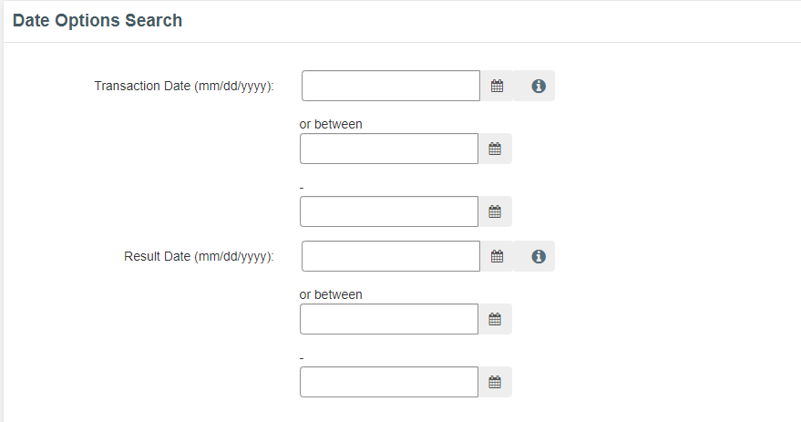
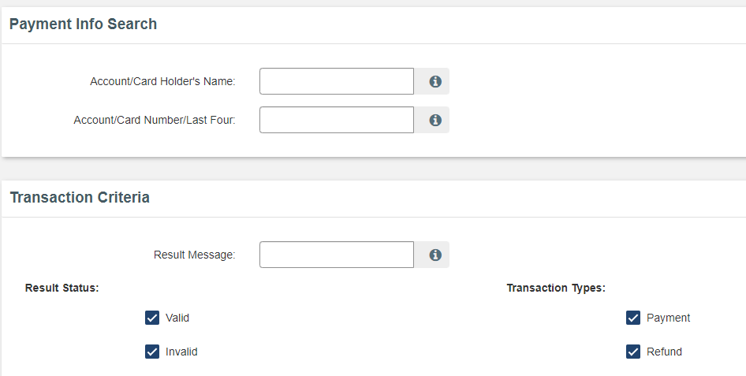
Transaction Results
Click on the magnifying glass in the Detail column to view the transaction details.
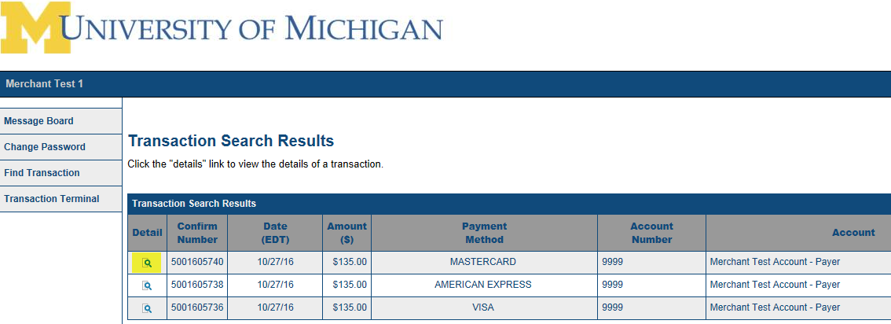

Transaction Details (Note: Refund button at bottom)
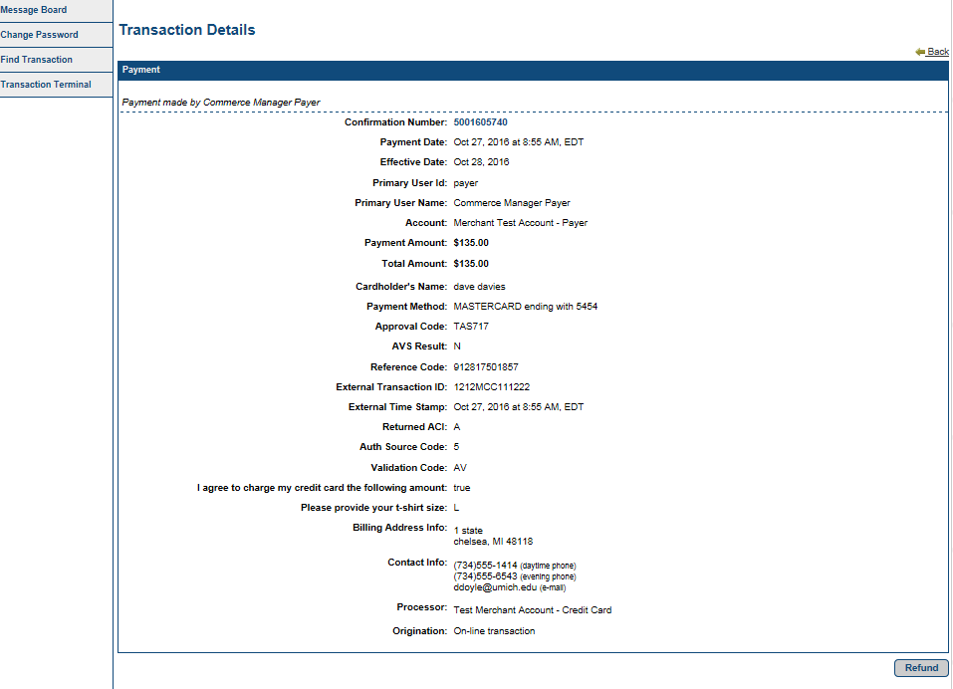

Issuing a Refund
When the correct transaction has been located and the Detail screen is viewed, simply click on the Refund button.

Enter the refund amount up to the original amount charged. Partial refunds are possible if desired. Then click Continue
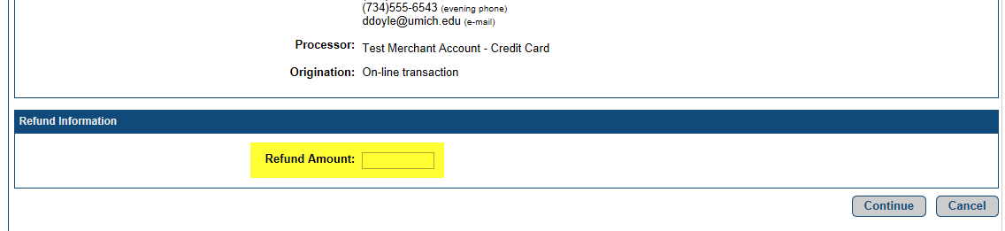

Confirm amount to refund. Select Confirm.
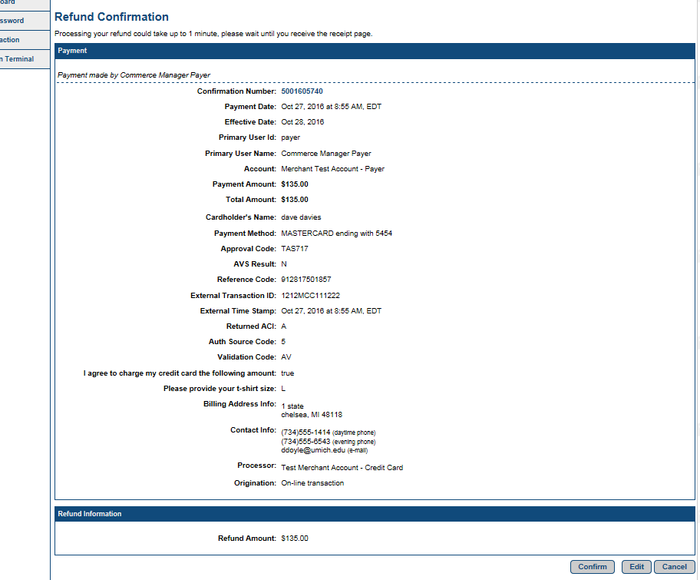
Print a copy of the Refund Receipt for your records.
