CampusGuard Portal Guide

Revised 3/17/2022

**CampusGuard** is the new 3rd party company that maintains UM merchants’ PCI compliance documents including the SAQs. Trustwave/SecureTrust was the previous vendor.

Specifically use this link to access the [CampusGuard website](https://cg.central.campusguard.com/portal#home/auth/SSO). You’ll be able to log in using your UM logon but the first time you’ll see the following screens. Click the down arrow and scroll to “University of Michigan.” Click on it.

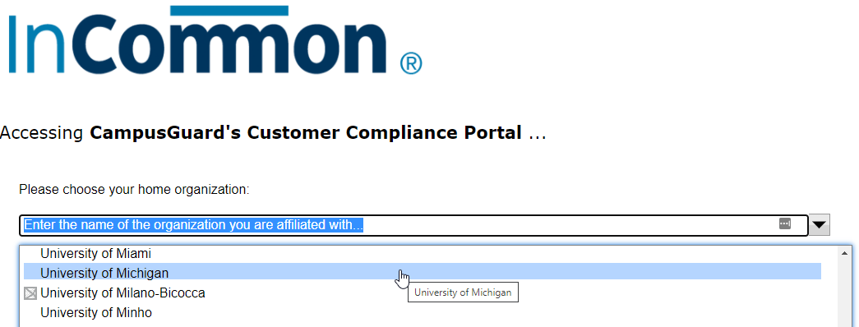

You should see the familiar UM weblogin screen. Sign on as usual. For Michigan Med merchants, enter your Level 1 credentials.

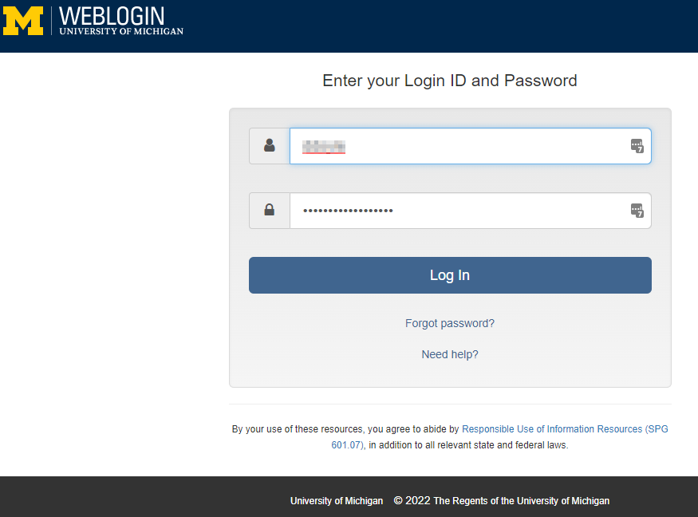

Click “**Confirm**”

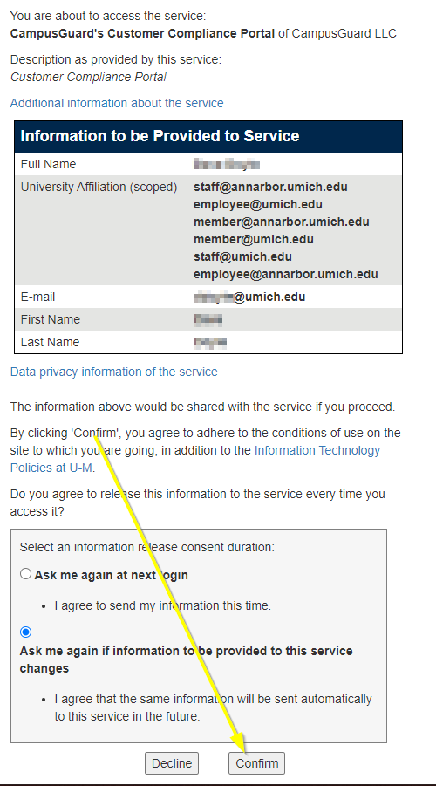

The main benefit of using this Single Sig-On (SSO) process is that you do not need a separate logon for CampusGuard. If you have multiple merchant accounts, you ***won’t*** need separate CampusGuard logons for each!

Once you log into the portal, you should be brought to the “**CampusGuard Central**” home screen. Click on the “**PCI Dashboard**” button.

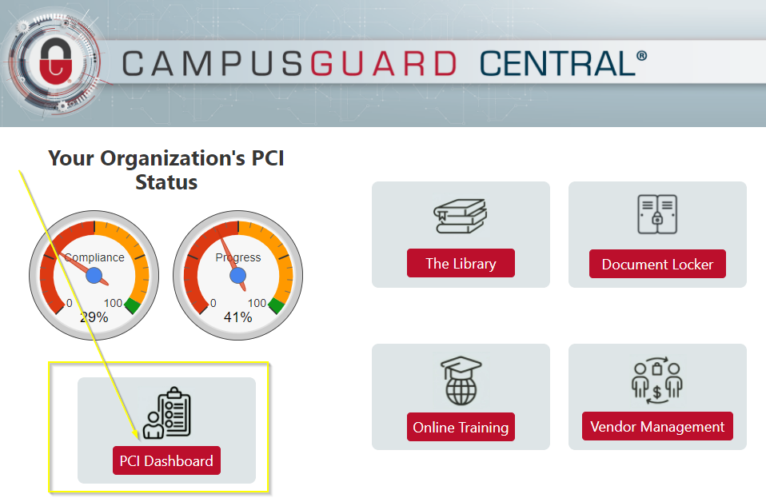

Click on the “**Edit SAQ**” button. This will bring up your Self-Assessment Questionnaire to complete.

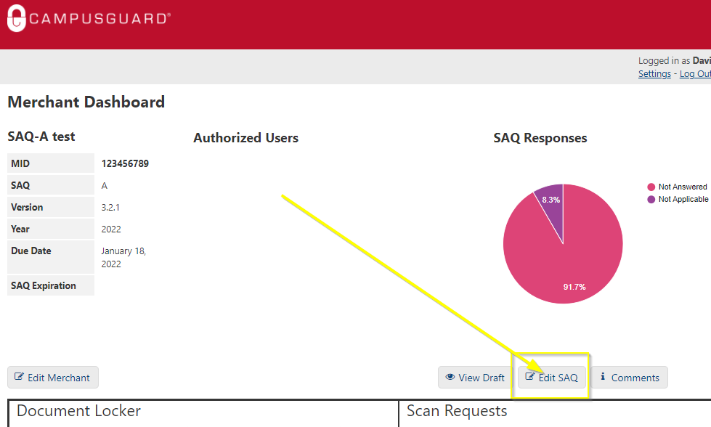

**Treasury has created** [**SAQ guides**](https://finance.umich.edu/treasury/merchant-services/pci-resources) **to assist those who complete SAQ A, SAQ B, SAQ P2Pe and SAQ D - for Mich Med units using Verifone VX520 terminals on the network.**