Rev 3/23/22

CampusGuard SAQ P2PE Guidance for Merchants using TrustCommerce with EPIC
Rev 2/16/22
NOTE:
- The annual PCI Self-Assessment Questionnaire (SAQ) P2Pe is only applicable for merchants who process EPIC credit card payments using the TrustCommerce P2Pe devices.
- Merchant never stores full credit card data: 16-digit card number or 3 or 4 digit CVC number, electronically or on paper.
- This guide is intended to provide assistance for the average merchant. Notes have been added for clarification. It’s important that you carefully read through the SAQ. You are attesting to the answers provided.
- If merchant also processes credit card transactions in a different manner (on a different merchant account), do not include that information in this SAQ.
- CampusGuard is the 3rd party company that maintains UM merchants’ PCI compliance documents including the SAQs. Trustwave/SecureTrust was the previous vendor.
- If you are not able to access the CampusGuard portal, email merchantservices@umich.edu. You will be able to use your UM logon to sign in.

Specifically use this link to access the CampusGuard website. You’ll be able to log in using your UM logon but the first time you’ll see the following screens. Click the down arrow and scroll to “University of Michigan.” Click on it.
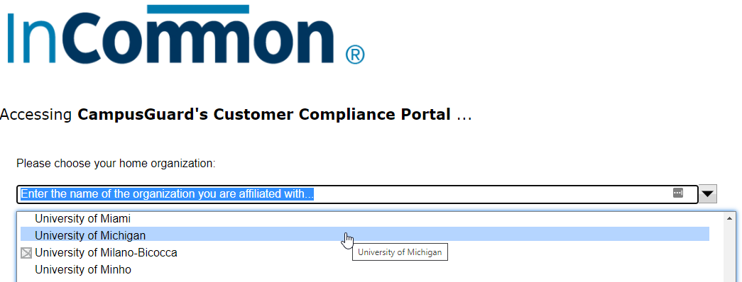

You should see the familiar UM weblogin screen. Sign on as usual. For Michigan Med merchants, enter your Level 1 credentials.
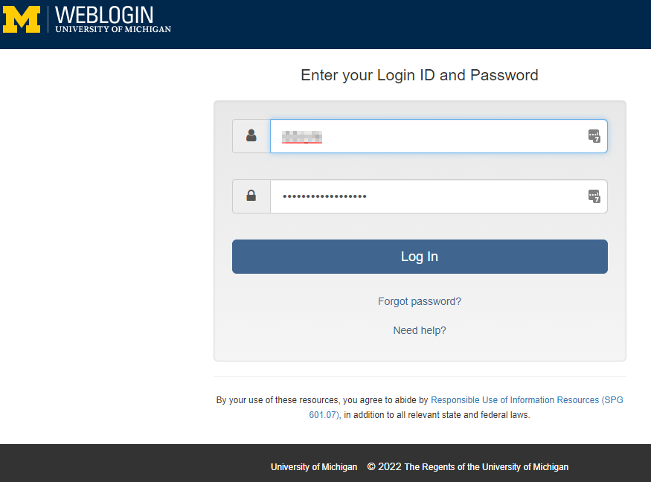

Click “Confirm”
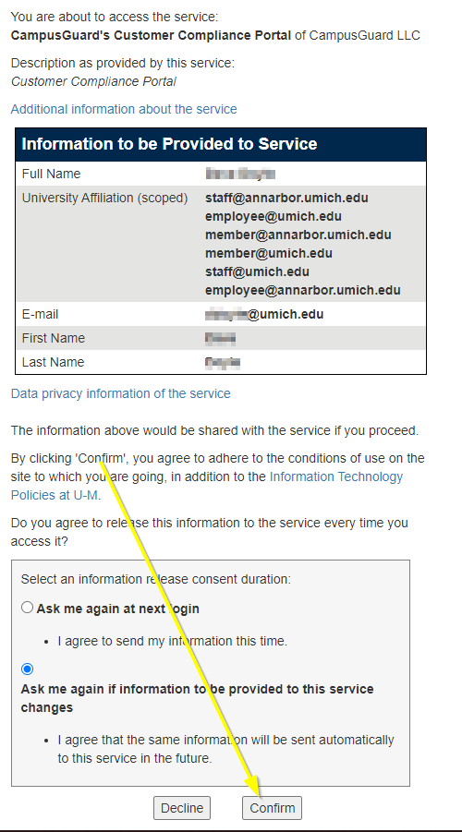

The main benefit of using this Single Sig-On (SSO) process is that you do not need a separate logon for CampusGuard. If you have multiple merchant accounts, you won’t need separate CampusGuard logons for each!

Once you log into the portal, you should be brought to the “CampusGuard Central” home screen. Click on the “PCI Dashboard” button.
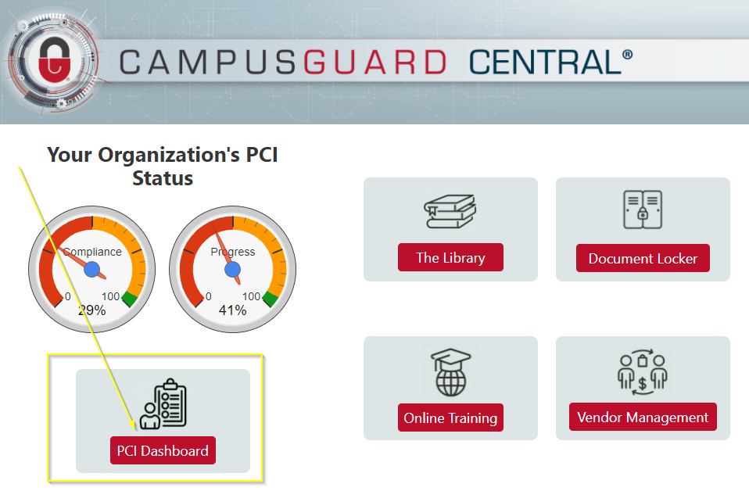
Click on the “Edit SAQ” button.
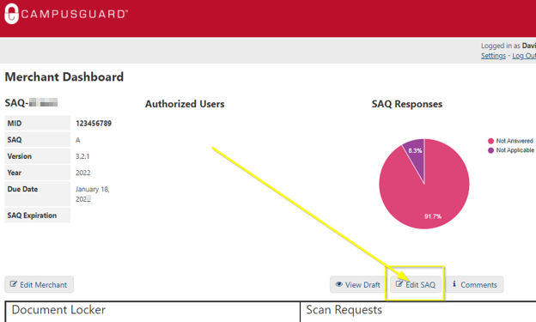

Verify the merchant information in Part 1a and correct if necessary. Enter information into any blank field (‘DBA’ is optional and leave ‘URL’ blank).

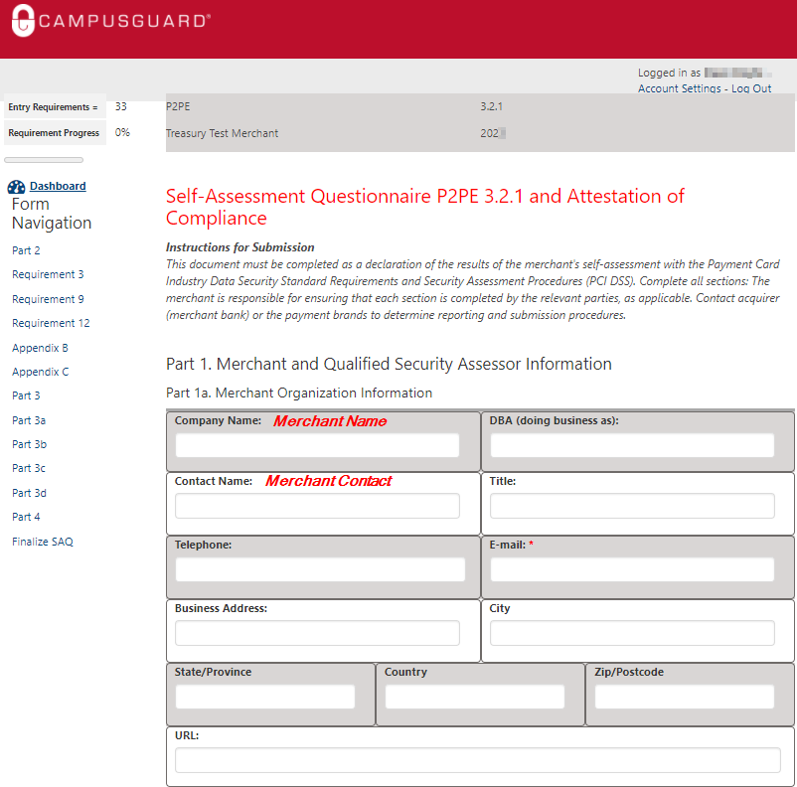

No input required. Simply click the “Save / Next Page.”

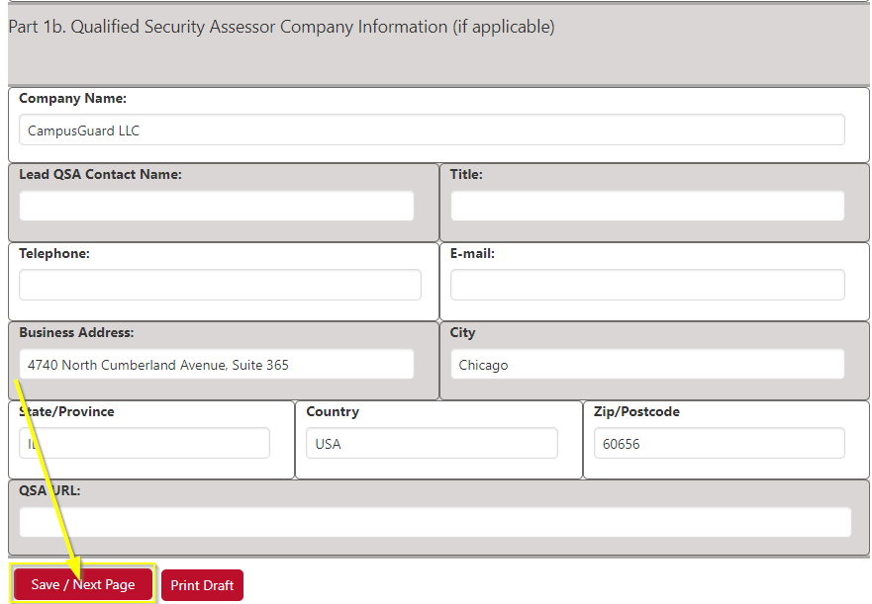

Part 2a
For most, click “Others” and enter a description of your business. “Health care” is also an appropriate description.
For the payment channels fields, check the box(es) how you take credit card payments. You’ll check the same box(es) in both columns.
Part 2b
A description can be similar to the following: “Merchant accepts credit cards using a TrustCommerce PCI certified solution integrated with EPIC for the sale of <generically enter what you sell at your office>.
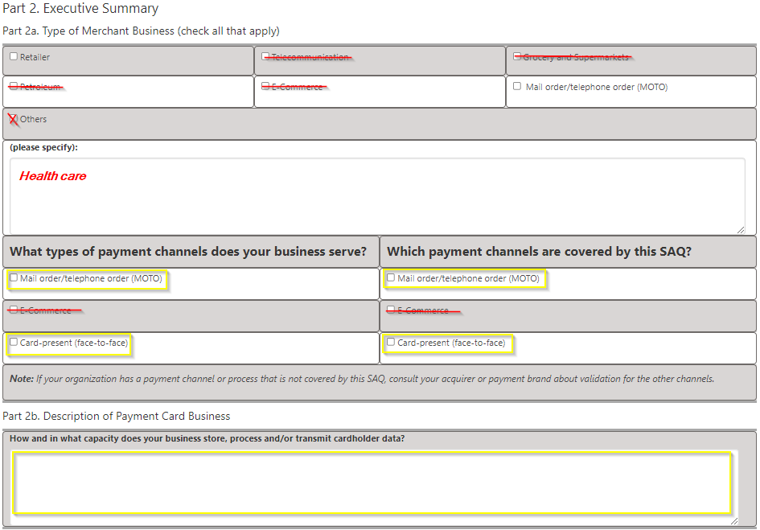

Part 2c
Enter your type of facility (retail outlet, clinic, business office, etc.).
Enter the number of facilities/locations - under the merchant account for this SAQ (generally it is ‘one’).
Enter your city and USA.

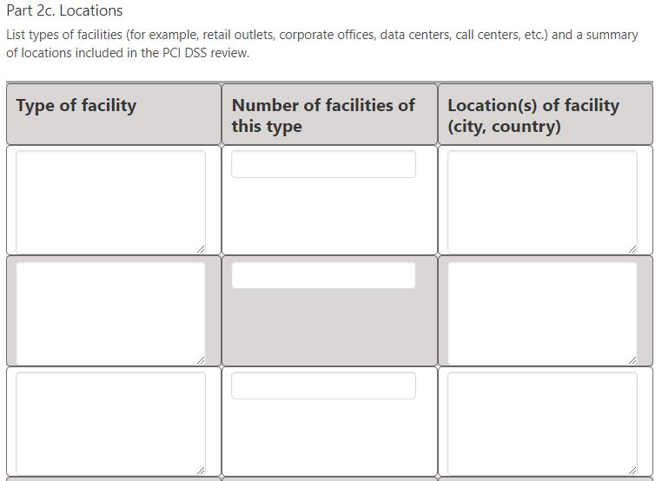

Part 2d
See comments in red below. Be sure to verify your credit card device make/model. It may be ID Tech SREDkey, although it could change over time.
Part 2e
See comments in red below.
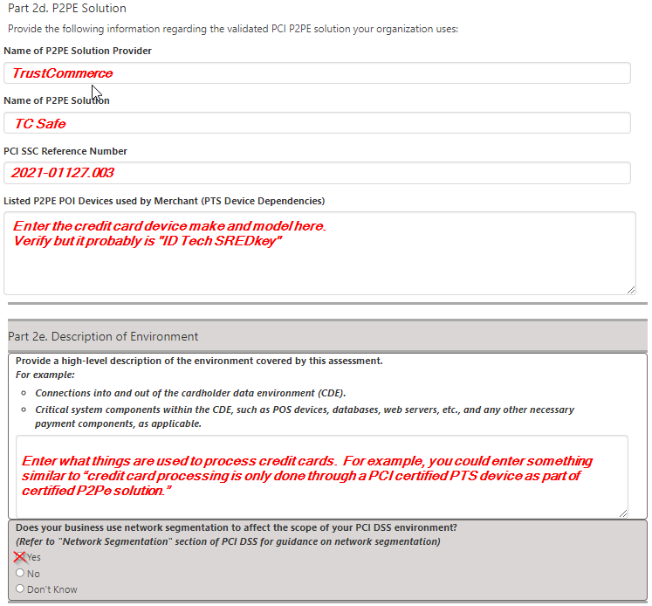

Part 2f
TrustCommerce is not a QIR. Click “No” for both questions below.

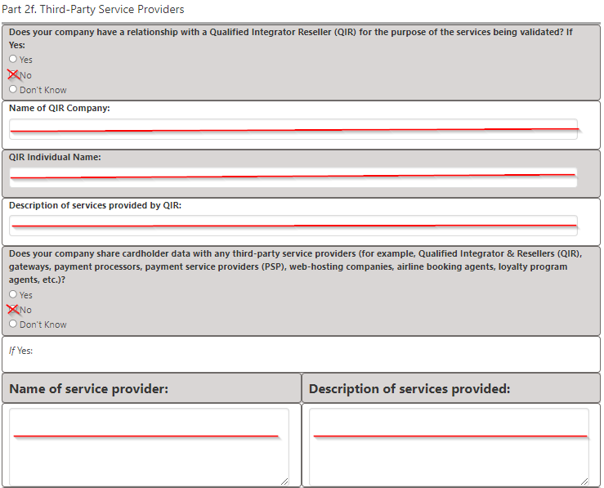

Part 2g
Please read the following statements. You should be able to confirm as a merchant that all of the items below apply. If so, click each box and then “Save / Next Page.”

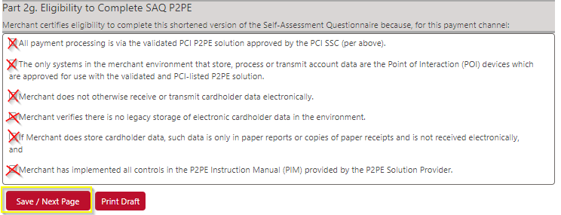

The next sections begin the SAQ P2Pe questions.
- Possible answers include: Yes, No, Don’t know, N/A, and Compensating Control Use.
- The most common are Yes and N/A. Entering N/A requires a written reason.
- Only use Compensating Control Use if Treasury or UM Info Assurance approve you to do so.

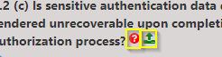
In each SAQ question, there is a red circle with question mark that you can click on for additional info. You can also ask questions to CampusGuard here.
Only a small minority of merchants would need to upload documentation for a question (the green up arrow symbol).

Requirements 3.1 a, b, c, d & e
See below. All should be “N/A” which requires a comment to be entered to the right.
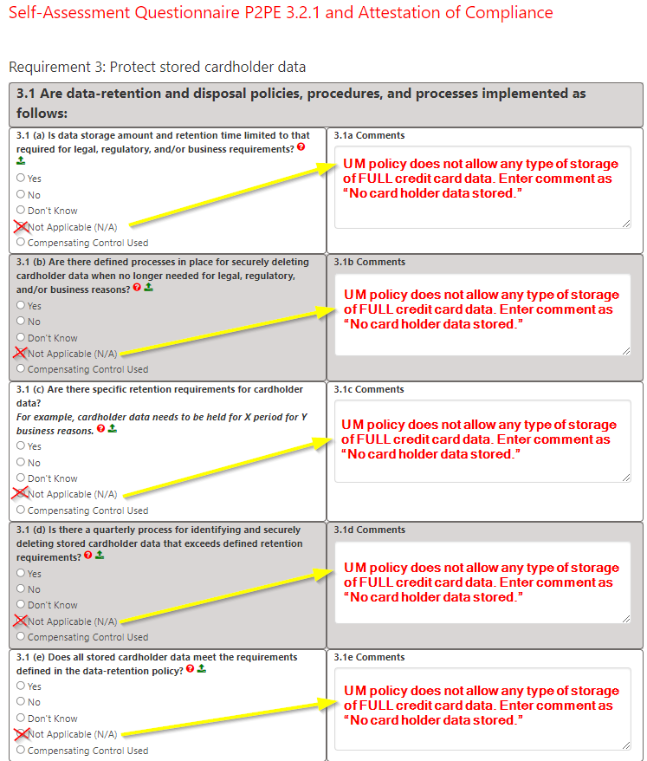

Requirement 3.2.2
See comments below. Click “Yes” if this is your practice.
Requirement 3.7
See comments below. Click “N/A” and enter the comment.
Click “Save / Next Page.”
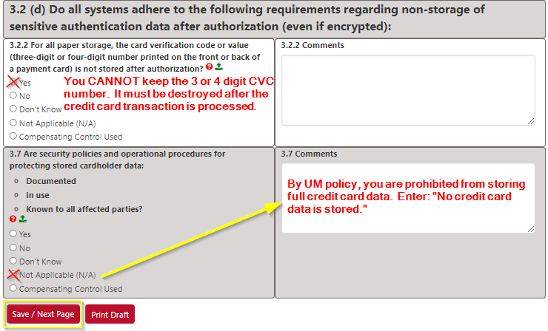

Requirement 9.5 – 9.8.1 b
See below. The standard answer is “N/A” and comment to the right. UM’s policy is that no merchants are to keep credit card data electronically or on paper after processing.
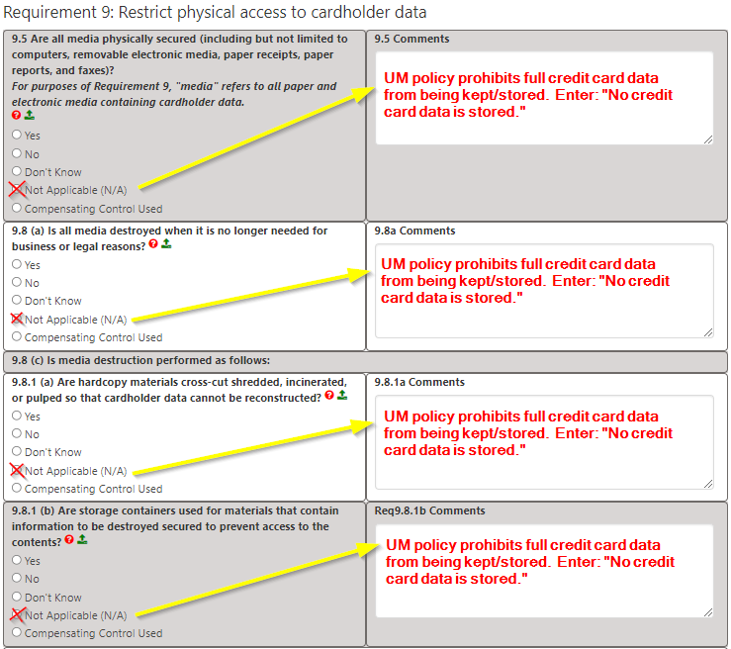

Requirements 9.9 a – 9.10
The standard answer is “Yes” for questions on this page and the next by virtue of adhering to the TrustCommerce P2PE Instruction Manual (PIM), UM Treasury Policy, and PCI Compliance.
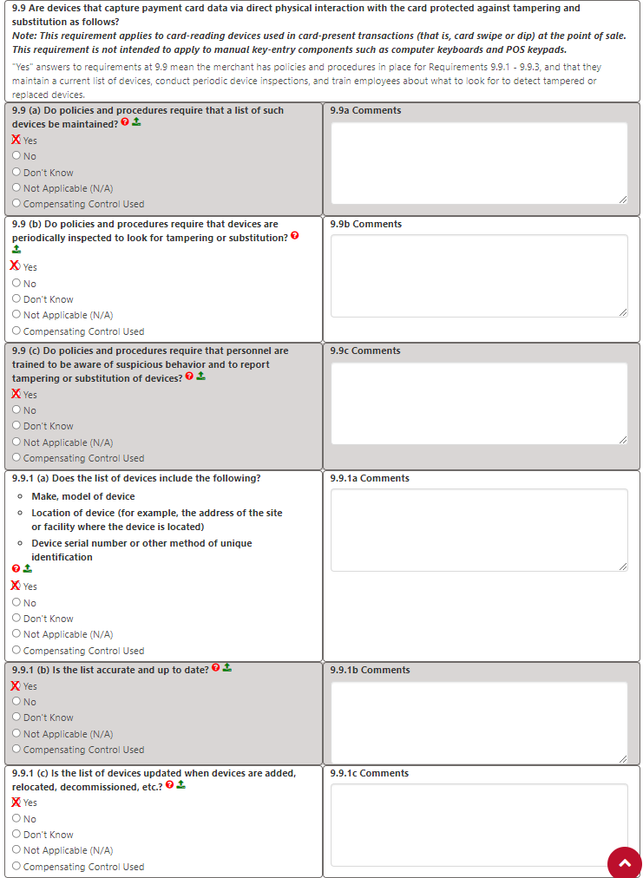

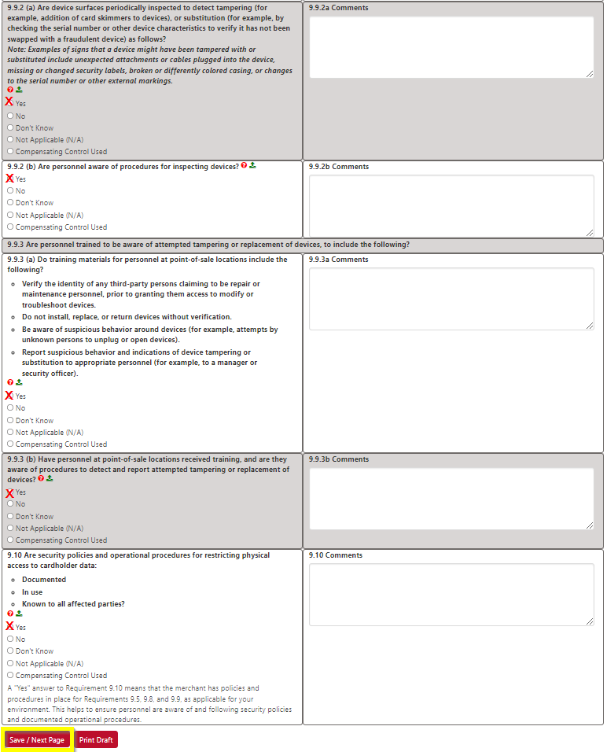

Requirement 12.1, 12.1.1 & 12.4
Merchants are to follow TrustCommerce & Treasury procedures on credit card terminal security, including terminal security after hours. Merchant is also responsible to immediately email merchantservices@umich.edu of full details if merchant staff become aware of a breach or a suspected breach of credit card data. Treasury will provide any additional steps for the merchant, if necessary.
Click “Yes.”
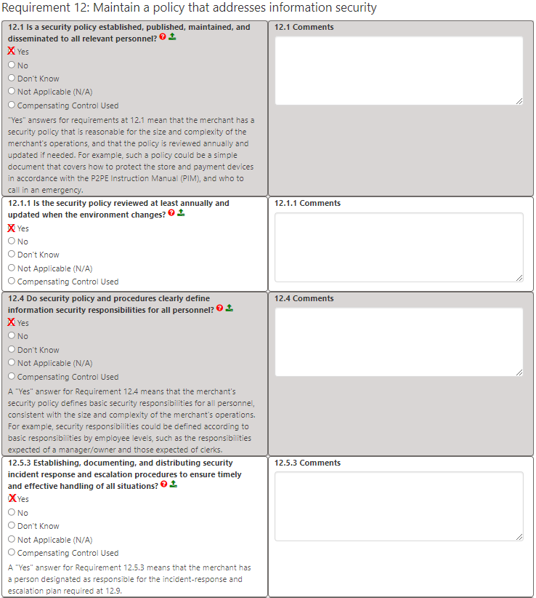

Requirement 12.6 a
Per TrustCommerce PIM, Treasury and UM Internal controls, Merchant Contact provides resources at least annually to staff on security of credit card data and transaction processing. This includes directing staff to terminal tampering training within the TrustCommerce PIM. All staff involved with credit card data must take/renew the UM My LINC TME102 course annually. If true, click “Yes.”
Requirement 12.8.1
All merchants are required to keep a current list of service providers that have or share credit card data and what services they provide. If true, click “Yes.”
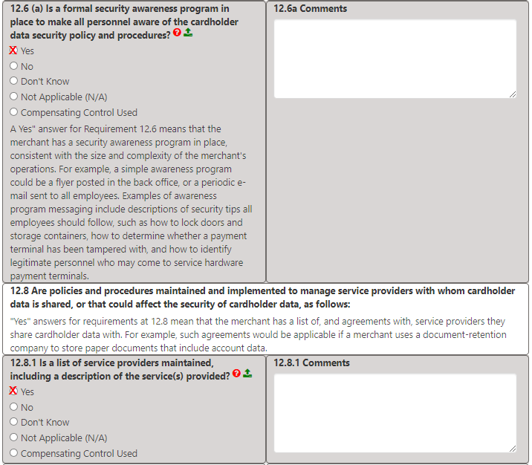
Requirement 12.8.2
In TrustCommerce’s agreement, there is language for their responsibility of cardholder data security. Click “Yes.”
Requirement 12.8.3
TrustCommerce was vetted during an RFP for cardholder data security before the contract. Click “Yes.”
Requirement 12.8.4
TrustCommerce must renew their PCI compliance annually. The Merchant Contact is responsible for verifying and documenting the TrustCommerce PCI renewals. If true, click “Yes.”
Requirement 12.8.5
Merchant Contact knows which PCI requirements fall under the TrustCommerce and those for the merchant. This is primarily found in the TrustCommerce PIM. If merchant contact is aware, click “Yes.”
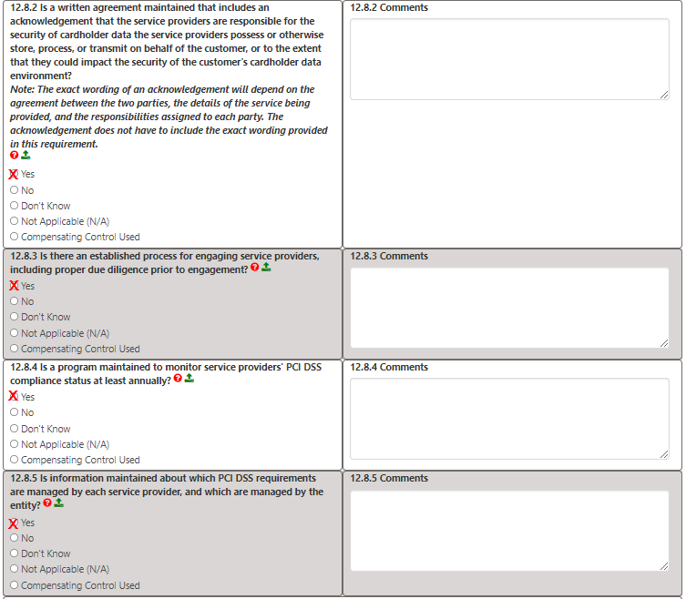

Requirement 12.10.1
UM has several incident response plans depending on the situation and level of data breach. The most important procedure for the merchant is to immediately email merchantservices@umich.edu with full details of a breach or suspected breach of credit card data. Treasury will review and contact the Merchant Contact with any further questions/instructions. Merchant Contact is responsible for training staff on this procedure and reviewing it annually.
Click “Yes” if the above is done.
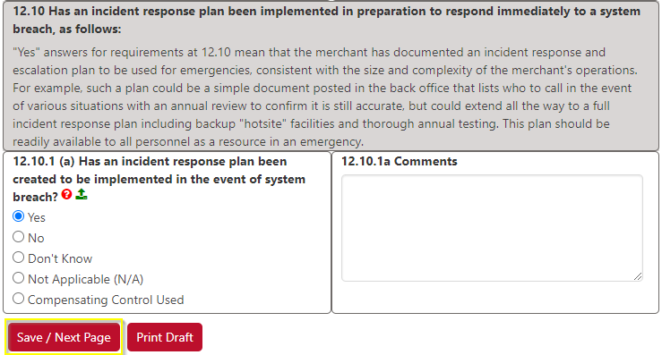

Appendix B
Unless you had answered one or more questions with Compensating Control Used, just click “Save / Next Page.”
Remember, you can only use Compensating Control Used if approved by Treasury or UM Info Assurance.
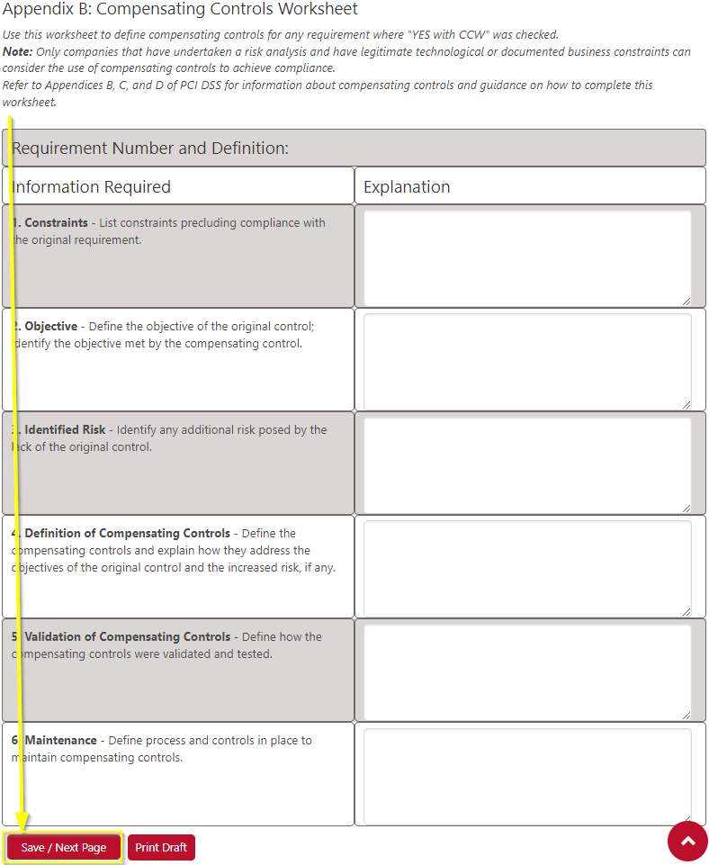

Appendix C
Click the “Populate Comments” button to bring forward all of the N/A comments. Click “Save / Next Page.”
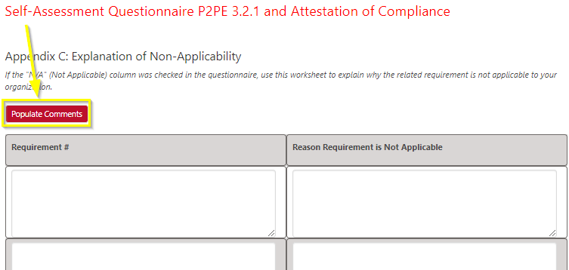

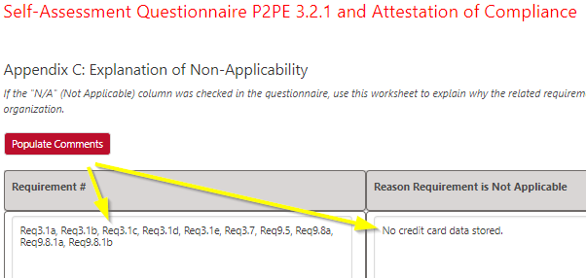

Part 3
If the “Compliant” box is checked, all of the questions have been answered. Click “Save / Next Page.”
If the “Non-Compliant” box is checked, review the previous Requirement questions for any not answered or for ones answered as “No” or “Don’t Know.” Make corrections.
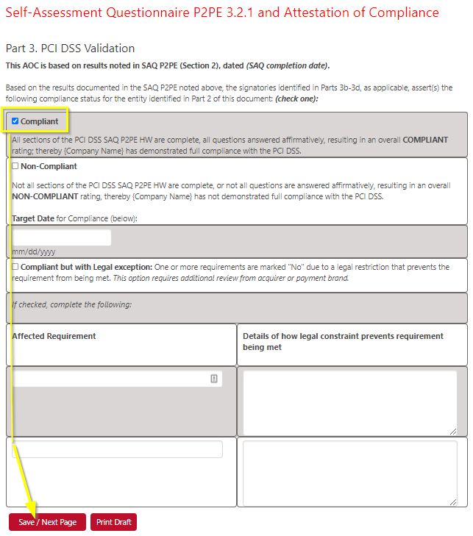

Part 3a
You should be able to agree/confirm to all of the check boxes below.
Click “Save / Next Page.”
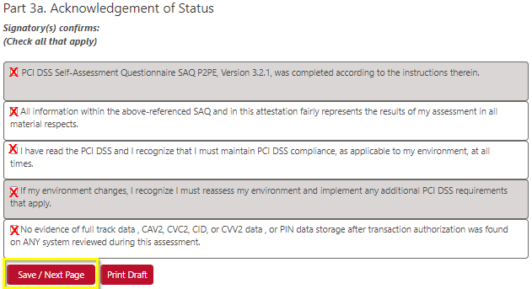

Part 3b
The Merchant Contact’s information is entered, even if a delegate has completed the SAQ. Click “Save / Next Page.”
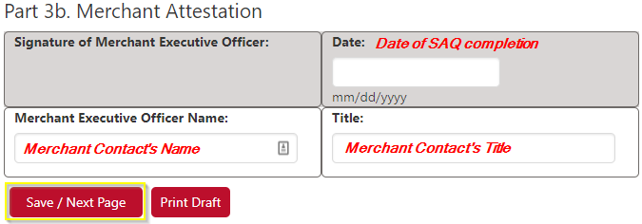

Part 3c
No input necessary, just click “Save / Next Page.”
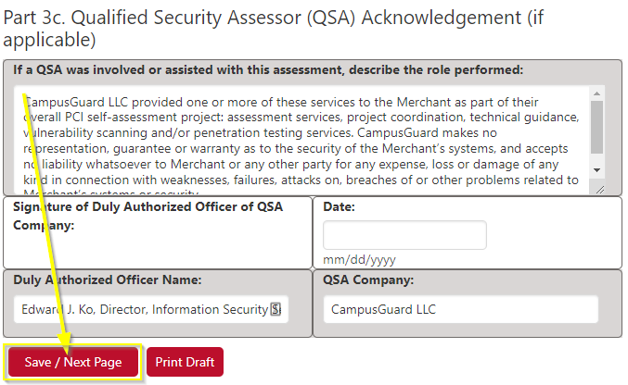

Part 3d
An ISA shouldn’t be necessary to sign off. Just click “Save / Next Page.”
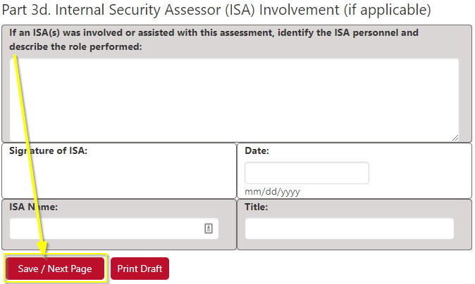
Part 4
Click “Save / Next Page.” Seek Treasury approval if you need to complete this section.
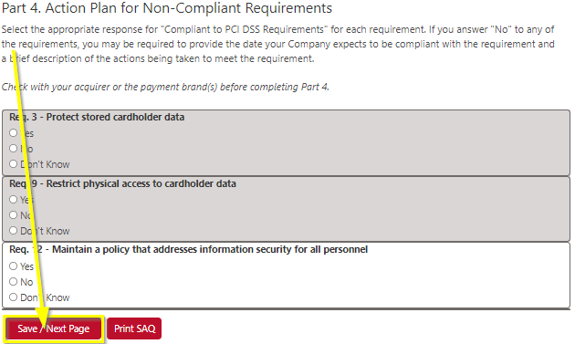

Read the options below and select the appropriate action for your situation.
NOTE: In order to officially finish your SAQ and be PCI compliant, you must click the “Complete & Lock SAQ” button.
Once this button is selected, you will not be able to modify your SAQ.

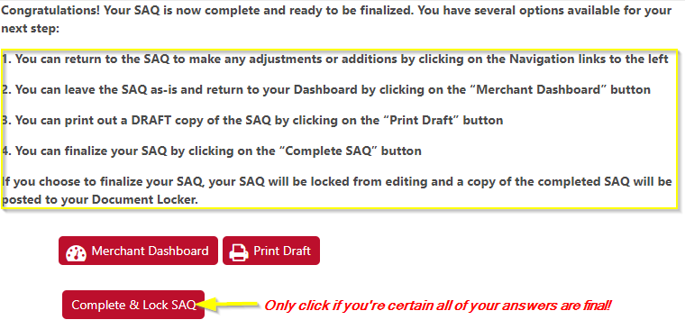

If you have completed and locked the SAQ, check for the completed SAQ in the Document Locker. If it is empty, click your Internet’s browser refresh button. It should look similar to the bottom image.
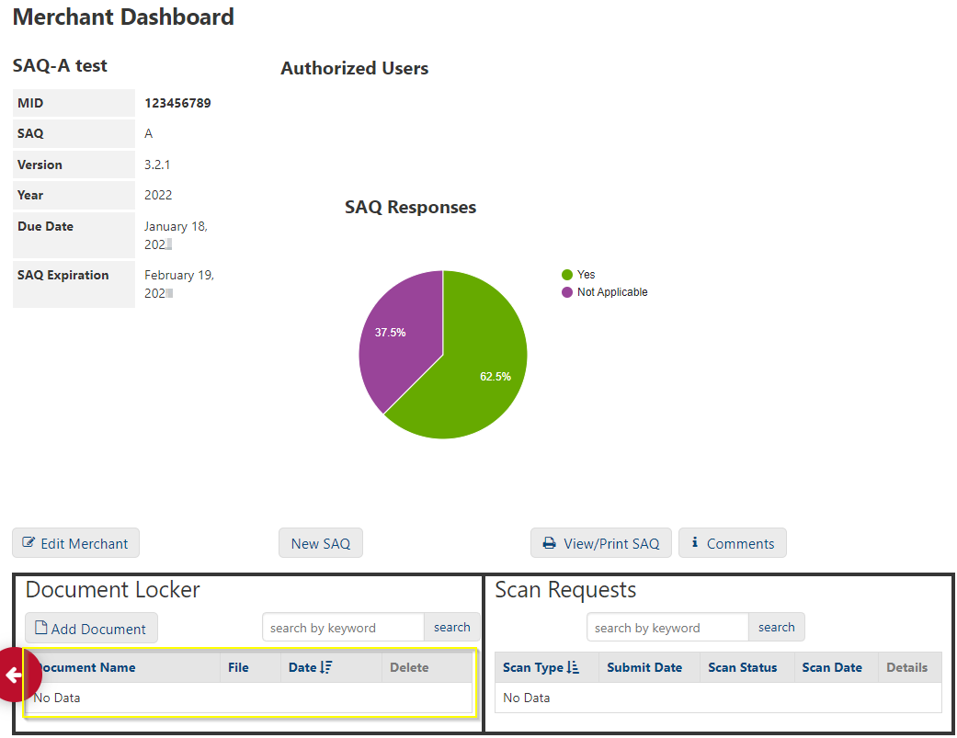
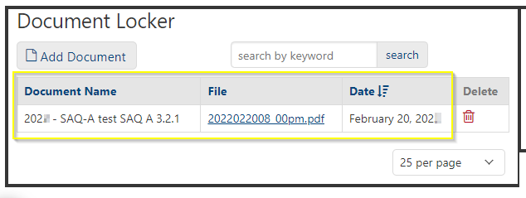
Congrats, you’ve completed the annual SAQ.
The SAQ is just one part of being PCI compliant. Don’t forget annual training, review of internal controls, etc. Contact UM Treasury merchantservices@umich.edu with any questions.

