How to Disable Auto Batch/Close/Settle on Verifone Credit VX520 Card Terminals

- From the normal “ready” screen, press 6.
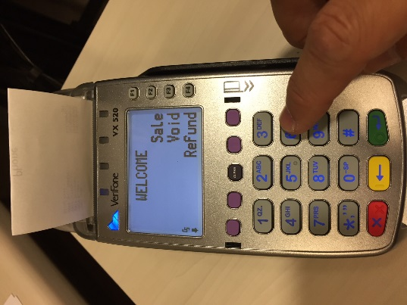
- Password: 11739 and press the Green enter button.
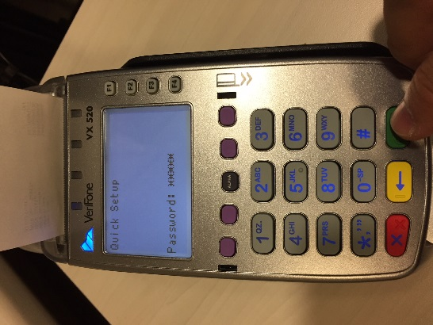
- Press F3 for terminal.
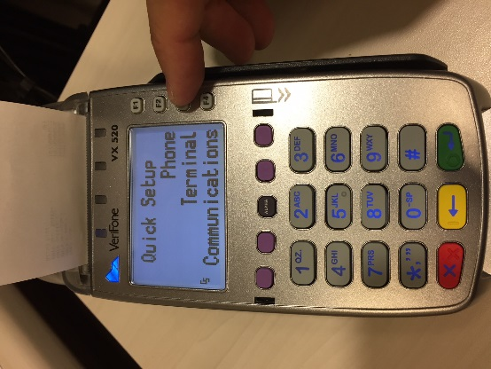

- Press F2 for View.
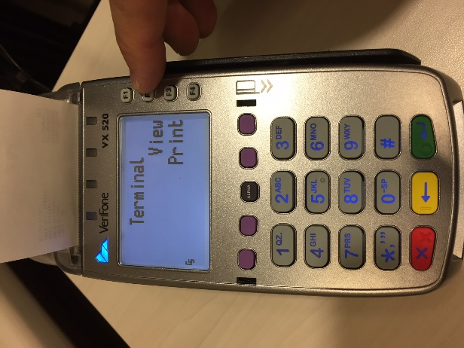
- Press F2 Next 10 times. (Continue past the ‘AutoSett Time’ screen)
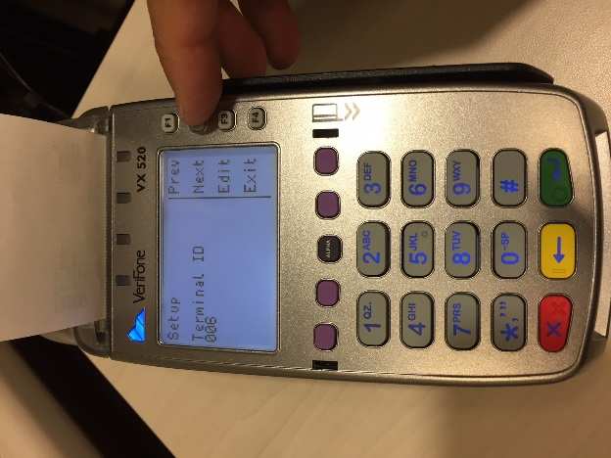
- Stop on the “Auto Settle?” screen (should display ‘ON’) and press F3 Edit.
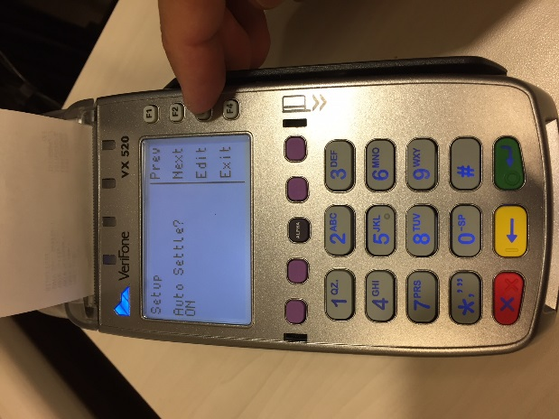
- Press F2 Off.
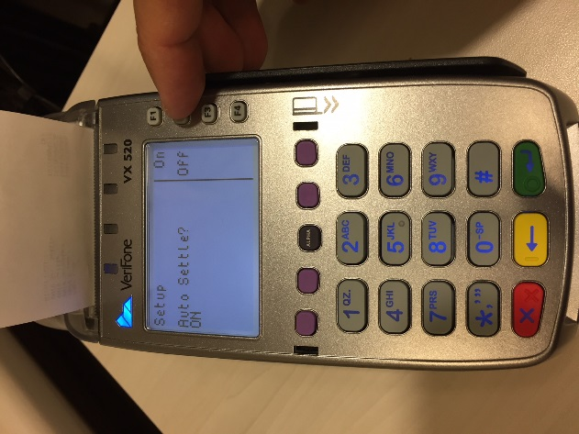
- OFF should be displayed. Press F4 Exit.
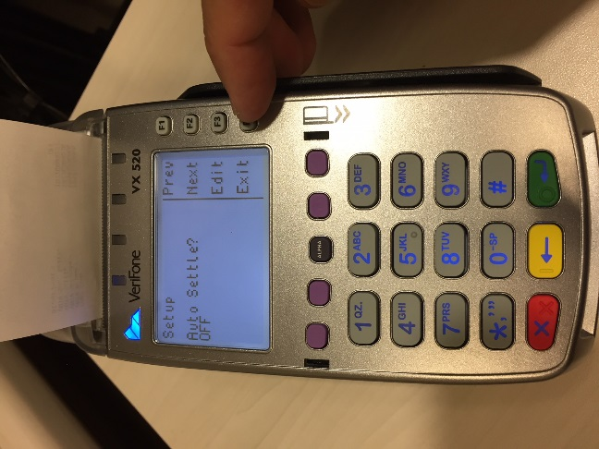
- Press Red cancel button multiple times to return to normal screen. You’re finished.
