Online Sub-Certification Departmental Input Step-by-Step

Overview
The Internal Controls certification process requires the Dean/VP to certify to various controls within their school/college/department group. However, many units require the individual departments to ‘sub-certify’ prior to the Dean’s or VP’s certification for the overall school/college/department group. The M-Reports Online Sub-Certification functionality provides units with the ability to sub-certify by responding to the certification tool online for each department ID within the unit.

Navigation
Log into Wolverine Access (http://wolverineaccess.umich.edu) > Faculty & Staff > Reporting > M-Reports.
M-Reports Landing Page
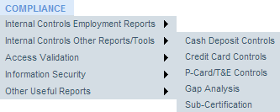  3  1  2 |  | - Hover over the COMPLIANCE tab.  - Hover over Internal Controls Other Reports/Tools.  - Click Sub-Certification.  The Sub-Certification Report includes a list of departments and their completion status for each section in the sub-certification tool.
Sub-Certification Status by Department Page
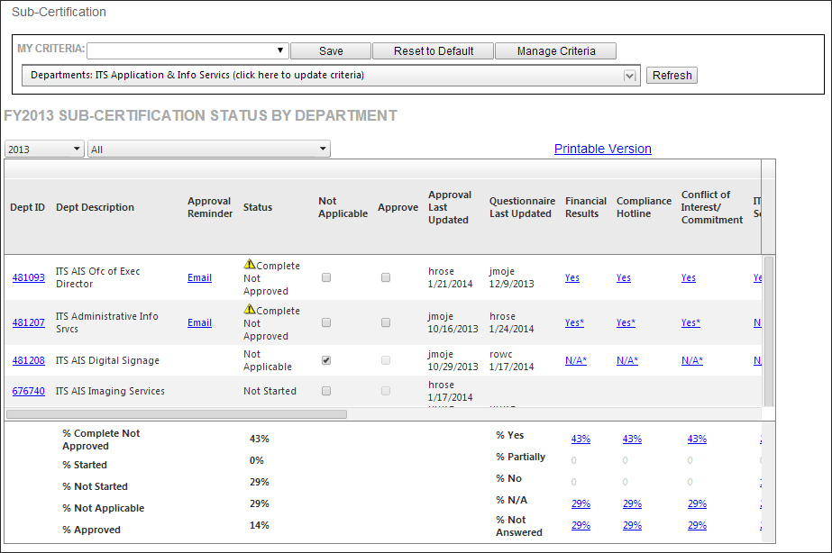  8  9  6  5  4 |  | - To view information for another year, use the Fiscal Year drop down menu.  - To display only departments at a certain status level, click the Show All drop down menu and select a new value.  - To mark all the controls Not Applicable for a department, click the box under Not Applicable for the affected department.  - Describe why the controls don’t apply to this department in Reason and click OK (not shown).  - To move to the right and view sections, use the horizontal scroll bar.  - To access a printable summary of the sub-certification answers for the department(s) listed, click Printable Version.
Sub-Certification Status by Department Page (continued)
12  11  10 |  | - To view a summary of the latest comments for a section for all departments listed, click the percentage link in the appropriate column and row.  Note: The complete comment history for each question is available on the Questionnaire screen.  - To view related comments, click the linked response indicator under any question.  - To send an email reminder to the designated approver for a department, click Email.
Request Approval screen
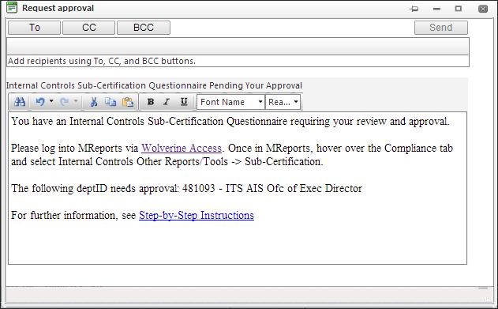  13 |  | - Click To.

Add Recipients Window
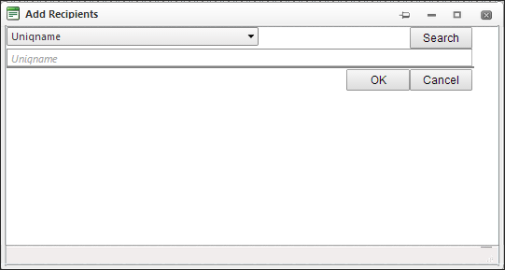  15  14 |  | - Type a full or partial uniqname of the approver in Uniqname.  - Click Search.
Add Recipients Window
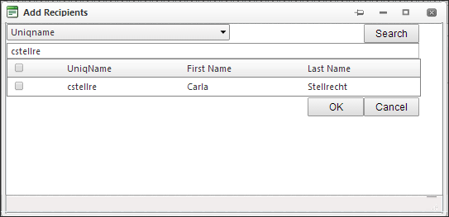  17  16 |  | - Click the selection box to the left of the approver’s uniqname and name.  - Click OK.

Request Approval Screen
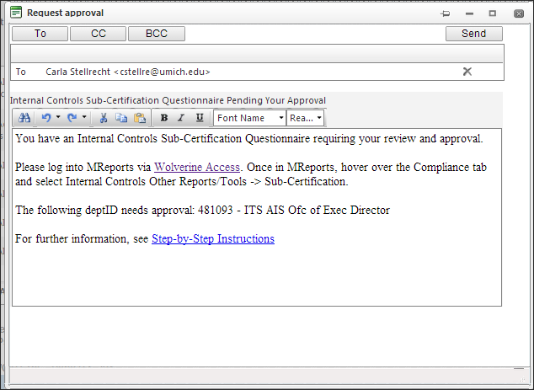  18  19  20 |  | - To change the standard subject line, delete the current text and type a new one.  - To change the standard message, delete the current text and type new text.  - Click Send.
Sub-Certification Status by Department Page (continued)
21 |  | - Click on the appropriate Dept ID to complete the questions for a department.

Certification Questionnaire Page
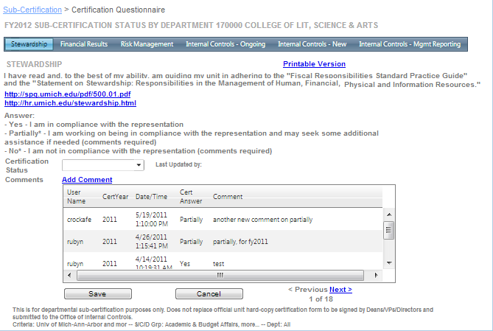  28  24  23  27  26  25  22 |  | - To navigate through the sections, click any of the tabs.  Note: Each section includes at least one question. Some sections include more than one question.  - To access a printable version of the complete certification, including questions, answers, and comments for a specific department, click Printable Version.  - To move through the questions in a section, click Previous or Next at the bottom of the page.  - Read the question, which is shown directly below the section tabs, and click any resource links provided for additional information regarding University policy or procedures.  - Select the answer from the drop down list in Certification Status.  - If applicable, click Add Comment and type comment text in the Comment box.  Important Note: Comments are required for ‘No’ answers.  - Click Save.

Related Resources
- Office of Internal Controls Web site: http://www.finance.umich.edu/controls
- Internal Controls Management Reports Web page: http://www.bi.umich.edu/products/internal_controls.html

Additional Assistance
Questions, feedback, and requests for enhancements can be submitted to the ITS Service Center: M-F, 7 a.m. - 6 p.m. (phone and email); Sun, 1 - 5 p.m. (email)
- Submit a Service Request Online: its.umich.edu/help/request
- Call: 734-764-4357 (4-HELP)
- Email: 4HELP@umich.edu

